One point crossover with roulette selection
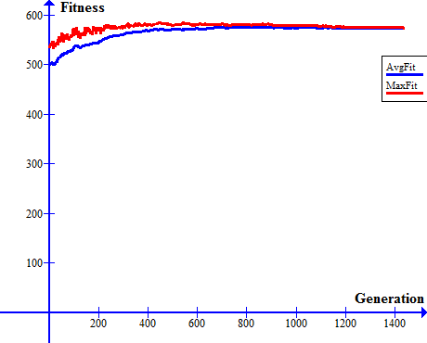

Uniform crossover with roulette selection

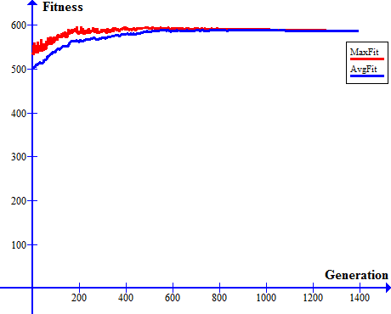

Source code:

generations.cs:

using System;
using System.Collections.Generic;
using System.Linq;
using System.Text;
using System.Threading.Tasks;
using System.IO;

namespace siit_1
{
class generation
{
List<int[]> gens;
List<int> fitness { get; }
List<float> probability { get; }
List<int> chromSelect;
public float averagefitness = 0f;

int rando = 0;

public generation()
{
gens = new List<int[]>();
fitness = new List<int>();
probability = new List<float>();
chromSelect = new List<int>();

for (int j = 0; j < 100; j++)
{
int[] gen = new int[1000];
gens.Add(gen);
fitness.Add(0);
probability.Add(0f);
chromSelect.Add(0);
}
}

public generation(List<int[]> new_gens)
{
gens = new List<int[]>();
fitness = new List<int>();
probability = new List<float>();
chromSelect = new List<int>();
gens = new_gens;
for (int j = 0; j < 100; j++)
{
fitness.Add(0);
probability.Add(0f);
chromSelect.Add(0);
}
}

public void randomize()
{
Random rand = new Random();
for (int i = 0; i < 100; i++)
{
for (int j = 0; j < 1000; j++)
{

gens[i][j] = rand.Next() % 2;
}
}
}
public void setFitness()
{
for (int i = 0; i < 100; i++)
{
for (int j = 0; j < 1000; j++)
{
if (gens[i][j] == 1) fitness[i] += 1;
}
}
}
public void setProbability()
{
int mass = 0; ;
for (int i = 0; i < 100; i++)
{
mass += fitness[i];
}
averagefitness = mass / 100;
for (int i = 0; i < 100; i++)
{
probability[i] = (float)fitness[i] / (float)mass;
}
}
public int[] newChild()
{

Random rand = new Random(DateTime.Now.TimeOfDay.Milliseconds + rando);
rando++;
if (rando == 10000000) rando = 0;
int rand_num = rand.Next(1000000000);
float sum = 0f;
int[] chrom_1 = new int[1000], chrom_2 = new int[1000];

for(int i = 0; i < 100; i++)
{
sum += probability[i]* 1000000000;
if (rand_num <= sum)
{
chromSelect[i]++;
chrom_1 = gens[i];
break;
}

}
//chrom_1 = gens[rand_num];
sum = 0f;
rand_num = rand.Next(1000000000);
for (int i = 0; i < 100; i++)
{
sum += probability[i] * 1000000000;
if (rand_num <= sum)
{
chromSelect[i]++;
chrom_2 = gens[i];
break;
}
}
//chrom_2 = gens[rand_num];

int[] new_chrom = new int[1000];

//unified crossover
//for (int i = 0; i < 1000; i++)
//{
// if (rand.Next() % 2 == 1) new_chrom[i] = chrom_1[i];
// else new_chrom[i] = chrom_2[i];
//}

//one point crossover
int point = rand.Next() % 1000;
for(int i = 0; i < 1000; i++)
{
if (i < point) new_chrom[i] = chrom_1[i];
else new_chrom[i] = chrom_2[i];
}

return new_chrom;
}
public int bestFitness()
{
return fitness.Max();
}

public void Sort()
{
for (int i = 0; i < 100 - 1; i++)
{
bool swapped = false;
for (int j = 0; j < 100 - i - 1; j++)
{
if (fitness[j] < fitness[j + 1])
{
int[] tmp_gen = gens[j];
gens[j] = gens[j + 1];
gens[j + 1] = tmp_gen;

int tmp_fit = fitness[j];
fitness[j] = fitness[j + 1];
fitness[j + 1] = tmp_fit;
swapped = true;
}

}
if (!swapped) break;
}
}
public float getAverageFit()
{
return averagefitness;
}
public void WriteTable(StreamWriter file1,StreamWriter file2)
{
for (int i = 0; i < 100; i++) {
file1.WriteLine(chromSelect[i].ToString());
file2.WriteLine(i.ToString());
}
file1.WriteLine();
file1.WriteLine();
}
}
}

Program.cs:

using System;
using System.Collections.Generic;
using System.Linq;
using System.Text;
using System.Threading.Tasks;
using System.IO;

namespace siit_1
{
class Program
{
static void Main(string[] args)
{
StreamWriter avgFitFile = new StreamWriter("averageFit.txt");
StreamWriter maxFitFile = new StreamWriter("maxFit.txt");
StreamWriter numGenFile = new StreamWriter("numGen.txt");
StreamWriter tableFile = new StreamWriter("Table.txt");
StreamWriter tablenum = new StreamWriter("Num.txt");
generation old_gens = new generation();
old_gens.randomize();
old_gens.setFitness();
old_gens.setProbability();
int maxFit = 0;
int numGeneration = 0;
for (int j = 0; j < 1000; numGeneration++)
{
numGenFile.WriteLine(numGeneration.ToString());
Console.WriteLine(old_gens.bestFitness() + " " + old_gens.getAverageFit());
if (old_gens.bestFitness() == 1000) break;
List<int[]> new_tmp = new List<int[]>();
//old_gens.Sort();
for (int i = 0; i < 100; i++)
{
new_tmp.Add(old_gens.newChild());
}
old_gens.WriteTable(tableFile,tablenum);
generation new_gens = new generation(new_tmp);
old_gens = new_gens;
old_gens.setFitness();
old_gens.setProbability();
avgFitFile.WriteLine(old_gens.getAverageFit().ToString());
maxFitFile.WriteLine(old_gens.bestFitness().ToString());
if (old_gens.bestFitness() > maxFit)
{
maxFit = old_gens.bestFitness();
j = 0;
}
else j++;

}
tablenum.Close();
tableFile.Close();
numGenFile.Close();
avgFitFile.Close();
maxFitFile.Close();
}
}
}

